Huntingdon County Mission, Vision, Values
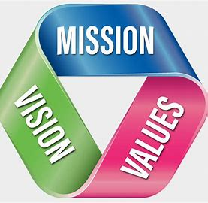
Our Mission:  Create a supportive, informed, and sensitive network to educate caregivers in order to ensure the safety and well-being of the children and youth of Huntingdon County. | Our Vision:  All children of Huntingdon County are safe, loved and protected by an empowered and invested community.
Our Core Values:
In recognition of the importance of self-care, both personally and professionally, the Agency believes that self-care is essential to meeting the following Core Values. The Core Values of the Agency are only at their best, when an individual is at their best.

Put Family First:  - Building work/life balance  - Responding in a timely manner  - Investing in every family and making them a priority  - Keeping an open mind to the individual values, culture, and responses of families | Be Respectful:  - Expect to be listened to and have a voice  - Show empathy and understanding  - Display genuine intentions to be helpful/supportive  - Value everyone | Be Honest:  - Portray clear expectations  - Afford transparency  - Be truthful with feedback  - Provide open communication | Work as a team:  - Patriciate in mentoring, training, and professional development  - Hold each other accountable for meeting expectations.  - Collaboratively share knowledge, resources, and information  - Have clear guidelines to achieve positive outcomes | Hope for Change:  - Encourage empowerment  - Assess strengths, needs, knowledge, abilities, and values  - Build on teachable moments to enhance knowledge, skills, and abilities  - Focus on strengths to overcome challenges  - Monitoring progress and making adjustments to reach identified goals

